WPA OM Regional Competition
Crunch Time Tips!

- Dress rehearsals

- Paperwork requirements

- Clarifications

- Preparation for Tournament Day/packing the car/survival bag

- Preparing the parents

- Respect for competition site (food/water policy) and fellow competitors

- Outside assistance (overall, spontaneous, long term, movement of props)

- Logistics of the day

- Understanding your scores

- Awards ceremony etiquette

- Advancers’ meeting

- Appreciation of the team’s journey!

Dress Rehearsal:

- When practicing, have the team start in a “staging area” before proceeding to the competition area.
- All parts of a problem solution and the containers they are shipped in must fit through a doorway that measures 28” x 78” (.71m x 1.98m), and they must be able to stand or be placed in an upright position in a standard room (ceilings 7.5-8 feet (2.28-2.43m) high). This applies to all containers holding parts of the team’s solution. A penalty will not be assessed if a part exceeds these dimensions; however, some tournament sites may not be able to accommodate them. Tournament Directors are under no obligation to provide time to disassemble and reassemble these items to bring them into the room and the team must not alter the building in any way.
- Vary the setup so the team is prepared to compete on a site that may be arranged differently than that shown in the problem. Review the 3-minute rule in the Program Guide.
- Teams have 8 minutes to present their long-term problem solution in competition.
- The team members need to consider what they will do if one of them cannot attend a competition for some reason. Keep in mind that this may happen unexpectedly.
- Videotaping a practice and letting the team members critique it is an excellent way to get them to improve their presentation in-school
- Teams should discuss and practice what they’ll do if something breaks or does not work.
- Teams should know whether it is better to continue with their solution and receive penalty points, rather than stop to fix something, since the points scored by continuing may offset the penalty points incurred for having something not work correctly.

Paperwork Requirements:

For forms and other resources online: odysseyofthemind.com

Log-in to member area:

Under Forms and Problems you will find forms needed for the competition and other useful resources.

Checklist for Competing in Long-Term

In competition, each team must provide the following items for its long-term solution along with any forms required by the local competition’s Tournament Director. The team members must fill out all of their forms on their own with the exception of Division I, where the coach may write for the team but the team members must dictate what is to be written. Teams should keep an extra copy of all their forms. Most of the following items will be examined and/or collected by the Staging Area Judge:

• Four completed copies of the Style Form.
• Four completed copies of the Team List Form (if required in the problem).
• One completed Cost Form.
• One completed Outside Assistance Form.
• One membership sign.
• Problem clarifications specific to the team’s solution.
• All props, costumes, etc. necessary to complete the problem solution, except those listed in the problem under “Tournament Director Will Provide.”
• Any items listed in the problem under “Team Must Provide

Cost Limit (Program Guide, page 45-47)
• The cost limit is the value of the materials used in the presentation of the solution at a competition.
• This includes the value of all items, including rented, loaned and borrowed items.
• Make sure the team fills out the Material Values Form (Program Guide Appendix). Detailed rules for completing the Materials Value Form are in the Program Guide, where you’ll also find a list of items that are exempt from cost.

Free Choice Selection for Style (Program Guide, page 22-24)
• The team should review the long-term problem solution and identify and list items or part of items that are not scored in the problem.
• The team should review the list and select items that it believes are the most creative.
• Be explicit about what the team wants to be scored (i.e., the construction of a costume or the use of materials, rather than the costume itself).
• Identify the items to be scored so the judge can find them easily. (Not “Joe’s costume” but “Construction of the clown’s costume”).
• Make sure the team prepares the Style Form (Program Guide Appendix). Style Judges use the synopsis on the team’s Style Form as a guide when scoring the team. It is essential that the team writes its synopsis clearly and expresses ideas succinctly!

Clarifications

Clarification requests end in mid-February, but, they may still continue to be posted. Be sure to check for these routinely.

Preparation for Tournament Day/ Preparing the Parents

- On tournament day the coach needs to spend time with the team, and not on fixing last-minute problems. Enlist help from the parents.
- Make sure the parents know the location of the competition site and the team’s performance schedule. Signs will show problem unloading locations by each school.
- Make a check list of things that the team needs (Program Guide, page 29-30):
- Props
- Repair kit (In an easily identifiable bag or box)
- Forms, including clarifications (Program Guide Appendix)
- Snacks
- Activities to keep them occupied as they wait to perform. It never hurts to rehearse one more time!
- Get parents to take care of transporting the props. Provide instructions on where and when to meet the team.
- Visit the problem site with the team early to become familiar with the layout of the site and the location of entrances, exits, and the Staging Area. The team needs to make any changes to their plan caused by the site setup well before their performance time.
- Unpack and check all props before you go to the competition site.
- Get to the long-term competition site at least 20 minutes early.
- Have parents assigned to take care of props after the competition- bring a dust broom/pan or something to clean up stray performance items.
- Get to the spontaneous site early enough so the team members can have some quiet time before they enter. Know how long it takes your team to warm up before starting spontaneous and what activity
- It’s not an odyssey competition without usually seeing some tears. Have your team take a deep breath and remind them that today is only a small part of their OotM Adventure!

Respect for Competition Site/Fellow Competitors

We are grateful to be able to hold the regional competition in such welcoming and state-of-the-art facilities.

- Have your team clean up after themselves wherever they go (prop storage, competition, cafeteria, etc…)
- Follow the spirit of odyssey in your interactions with other teams, judges, Moon district employees, etc…
- Only eat in designated areas (cafeterias and concessions table area before Awards). Water only is allowed outside of those areas.

Outside Assistance

Continue to follow Outside Assistance guidelines.

Don’t share your solution until after World Finals. This includes posting it online. Also, don’t trust ideas, solutions, suggestions, etc. that others provide.

At competition, others are allowed to help the team transport props and other problem
materials into the Check-In and Staging Areas. However, others may not help the team assemble backdrops or anything else, or apply makeup, fix costumes, etc. If they do, the team will receive an Outside Assistance penalty. Outside Assistance penalties are based on the judges’ observations and/or the team’s statements, not on hearsay from others.

Logistics of the Day

Teams will receive their tournament competition times prior to tournament day. There are maps of the building on the regional web site, so, familiarize yourself with where your team will be competing.

Signs outside and inside of the middle school and high school will direct you to where your problem/division is competing. There will also be signs for your prop storage area. Please be mindful of space considerations and do not infringe on another team’s space.

Team packets are available at the building where your team will compete for long term.

Give yourselves plenty of time to arrive, unload, and transport items to prop storage before your scheduled competition times. There will be many teams unloading, so, extra time will help with being patient.

Check-In/Staging: The Staging Area Judge will meet with the team in the Check-in/Staging Area. Generally, if a competition site requires doors to be closed when teams are performing, the Check-in/Staging Area is outside of the competition room. This is where the Staging Area Judge will meet the team to collect paperwork, check foot coverings, and so on. When ready, a judge directs the team to come into the competition room and wait in the Staging Area for its performance to begin. The team will move all of its materials from the Check-In Area into the Staging Area. Any materials remaining after approximately 3 minutes may be moved by the judge to allow the next competing team to enter the Check-In Area. When the team is in the Staging Area and the judges are ready, the 8-minute performance time will begin and the team may start its performance while setting up. The set-up of the check-in/staging area my vary depending upon the performance site.

With the team’s permission, others not on the team may help to move problem solution items into the Check-In Area and the Staging Area. Others may also help the team remove items from the competition site when directed by the judges. However, until the team is dismissed, no one may enter the competition site

Understanding Your Scores

Long-Term Scoring
The team earning the highest score for each long-term problem and division in a competition is awarded 200 points unless the problem states otherwise. Every other team receives a percentage of 200 based on its raw score in relation to the highest raw score. Any penalty points are deducted after scores are calculated. No team will receive a score below zero for its long-term score. There are two types of scoring categories for the long-term problems:

(1) Subjective scoring categories are generally based on creativity, quality, effectiveness, humor, and other areas that are qualitative and an opinion of the judge. These are scored on a sliding scale, such as 1 to 15 points.

(2) Objective scoring categories are based on whether or not the team completes certain requirements of the problem. These scores are absolute, such as 0 or 5 points. An example of objective scoring is, “The vehicle crosses the Finish Line.”

Long-Term Style

Style is an added element that enhances the presentation of the solution. The Style portion of the competition gives teams an opportunity to further showcase their talents and creative skills and to elaborate on their long-term problem solution. Each problem has its own required Style elements, as well as Free Choice Style categories that are determined by the team.

Scoring Style
Each long-term problem lists five Style categories. Categories one through four are either specific scoring elements or “Free choice of team.” The fifth category is always “Overall effect of the four Style elements in the performance.” All Style categories are scored subjectively, and each is worth 1 to 10 points, for a maximum of 50 points.

To receive score for Style, the team must complete a Style Form (see Appendix) and
present four copies to the Staging Area Judge. The team must list the first four areas to be scored and explain how they relate to the long-term problem solution and how they contribute to the overall effect of the performance. Teams must be very specific when explaining their Style categories.

In technical problems, a team may present its Style elements even if the technical
components of its solution are not successful. A skit or performance is not necessary to receive score for Style.

Scoring Spontaneous
In competition, the spontaneous problem is worth up to 100 points. The team with the highest raw score in each problem receives 100; every other team receives a percentage of 100 based on its raw score. Spontaneous scores are the decision of the judges in the room.

Competition Scoring
The team that earns the highest raw score in its division and long-term problem is awarded the maximum score. All other teams receive a percentaged score based on the maximum raw score.

The same percentage-based scoring applies to the spontaneous problem competition and Style.

The total combined long-term, Style, and spontaneous percentaged scores (with penalties deducted) determine the winners in each problem within each division.

Getting Long-Term Scores
On competition day, before the awards presentation, judges will tell coaches when and where they can pick up the team’s long-term raw scores. Teams will have the opportunity to get a copy of its averaged Style scores.

Coaches will be asked to initial their team’s scoresheet to verify the time they received it.

Once coaches review the team’s long-term raw scores with the judge, they have 30 minutes to raise any questions. All raw long-term scores become official 30 minutes after the last team in a problem and division has competed, even if a coach has not taken the opportunity to review the team’s long-term score. If a coach is denied a review, they should report to the problem captain.
Only long-term raw scores and averaged Style scores are given to teams; individual longterm, style and spontaneous raw scores are not provided to the teams

Awards

There is a break between the final performance and the awards ceremony. This is a good time to:
- Clean up prop storage area and pack your team’s stuff back into your vehicles.
- Get a bite to eat- can go to a local place depending upon how early you finished, or, it is nice and convenient to support the Moon groups selling concessions.
- Buy auction tickets to support our Odyssey of the Mind program- costs to host the regional event are increasing.
- Enjoy the DJ and slide show in the gym- let the kids dance on gym floor while parents can relax and chat in the bleachers.
- Remind your team to give everyone the courtesy of their attention and applause during the ceremony- whether it is a speaker or a team being recognized.
- Do not leave until the last award has been given- every person/team deserves the same respect regardless of what order they received recognition.

Advancers Meeting

After the Awards Ceremony there is a brief meeting for teams that are advancing to the State Competition. It is very important for a coach to attend this meeting as information will be disseminated which will need a quick turn around time for some responses.

Appreciation of the Team’s Journey

While the ultimate goal for most teams is to present their problem solutions in official competitions, this is not a requirement of participation. The purpose of the program is to provide students with an exciting learning experience that promises to be challenging and fun.

Celebrate your team’s journey and growth, regardless of how they place in the tournament. Consider having a get-together to talk about the year, and to enjoy some relaxed time as a team. Maybe even have the parents do some spontaneous problems and let the kids be the judges!

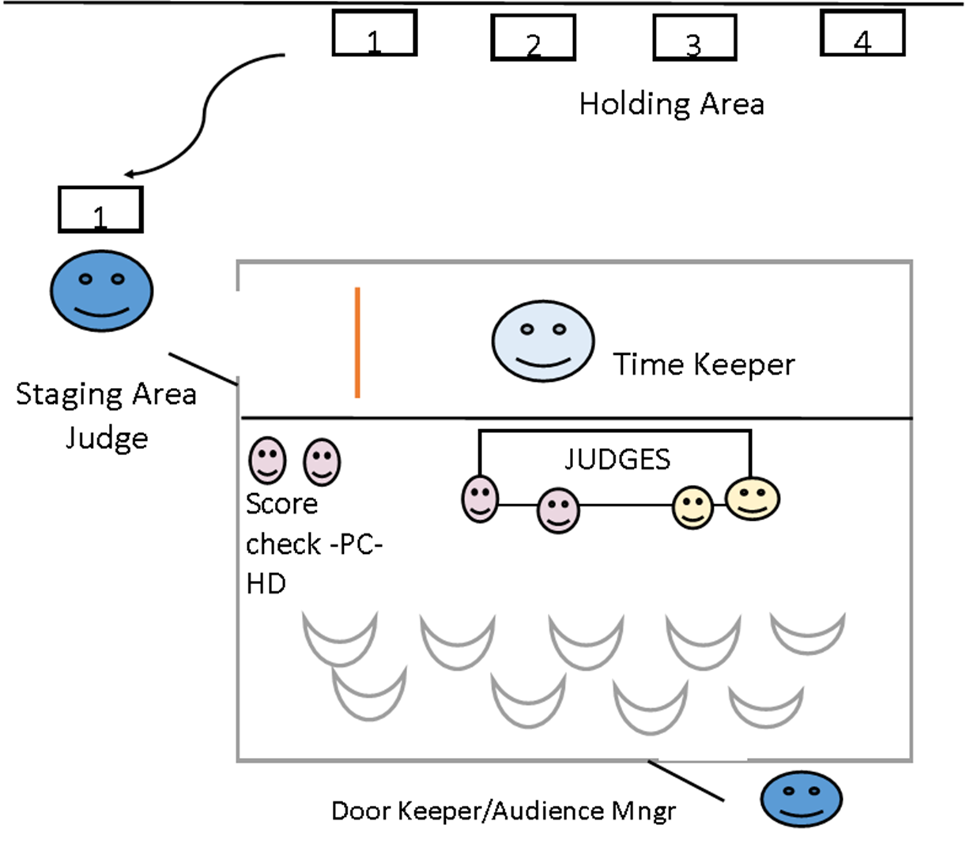

Staging Area Judge – Greets & relaxes teams. Checks paperwork. Gives teams the chance to fix anything that is wrong or missing.
Timekeeper/Announcer – Takes paperwork to the judges. Announce the teams to the audience.

Problem & Style Judges – Scores different parts of the solution. Congratulates the team after its performance. Asks questions in a warm manner that prompt the team members to talk and even brag about their solution. Such as, “Where did you get the idea to make it a…” Be sure to know which judges are looking at which elements and direct comments about those things to them. For example, make sure the team knows to talk to a style judge when telling them about style elements.

Scorechecker – Makes sure the scores are in range and are compiled correctly.

Head Judge – Manages the judging team. Meets with the coach and gives the scores before they are entered into the scoring program.

Door Keeper/Audience Manage – Monitors door so it is closed during the performance. Monitors no food and drink in competition spaces.

